ANSWERS(ASSIGNMENT 6)

1)The “ls” command is used to list the contents of a directory.
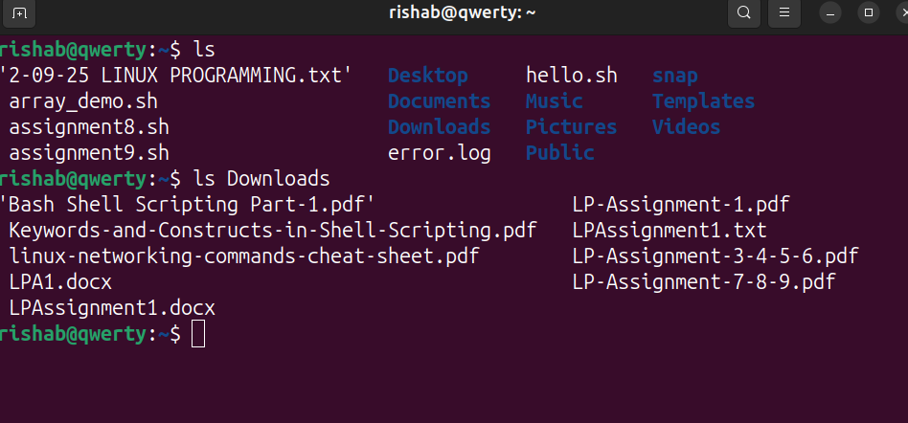

2)The command to create a new directory is “mkdir”.

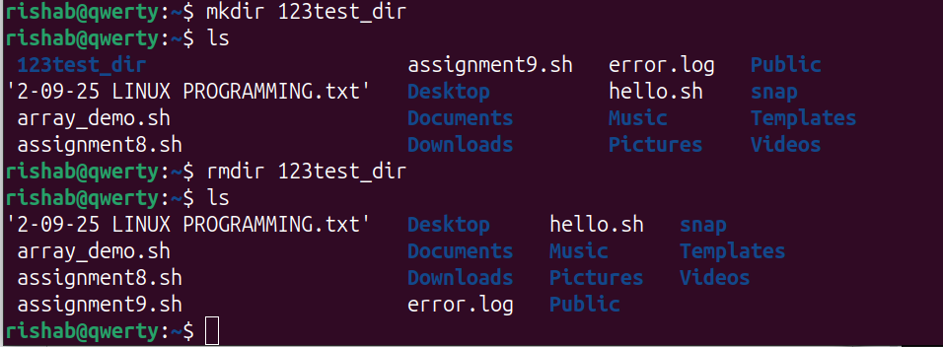
The command “rmdir” removes a directory.

3)The “sed” command is a stream editor used to perform basic text transformations on an input file. We can use this tool to make quick edits to files or streams of data.
For example:

Lets create a file named “sed.txt” using the touch command.

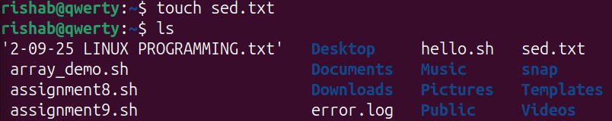

Next, let's insert a text using the “tee” command.

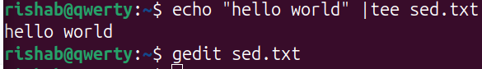
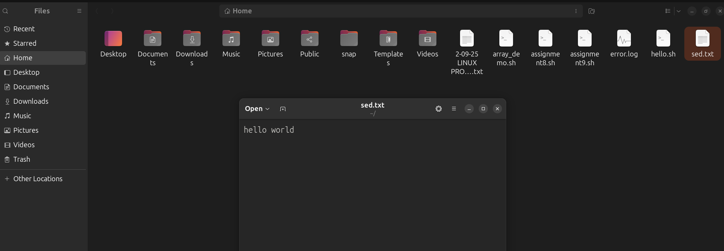

Using the “sed” command we can replace the word “hello” with “hi”.
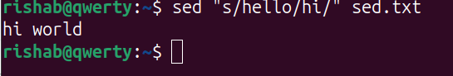
Now this only changes the output in the terminal but in the original file it will remain the same. In order to replace the word in the original file we have to use the “-i” flag.
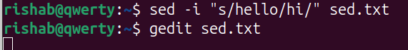
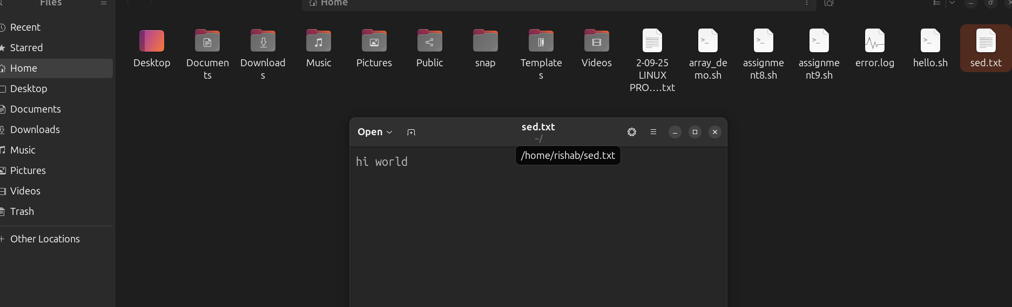

4)The “whatis” command is used to display a one-line description of any command.
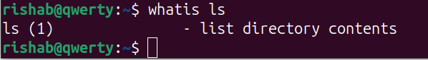

5)The command to create a flie is “touch”.
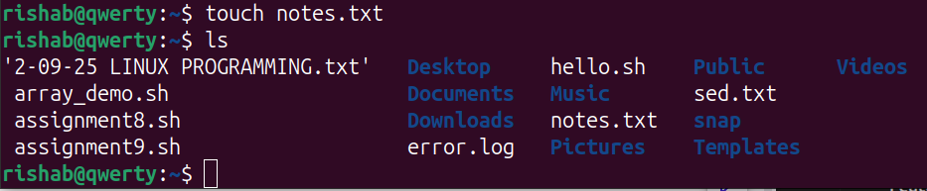

6)The “grep” command is used to search for text patterns within files.it is a powerful way to find specific text in large files or across many files.
The “awk” command is powerful for text processing. We can use it to extract specific fields from a file or perform calculations.

GREP

1.Used mainly for searching text or patterns in files.
2.Works line by line, printing lines that match a pattern.
3.Simple tool-only matches and prints lines.

AWK

1.Used for pattern scanning, text processing and data extraction.
2.Works on fields within lines and can perform calculations or formatting.
3.More powerful-can filter, format and compute using built in variables and expressions.

7)The command to give read, write and execute permissions to the owner of the file “script.sh” is
“ chmod u=rwx script.sh “
OR
“ chmod 700 script.sh “

8)The chown command is used to change the ownership of files and directories in Unix-like operating systems. It allows you to set which user and group own a file.
chown rishab:developers file.txt (here ownership is being passed to user ‘rishab’ and group ‘developers’.)
The chgrp command is used to change the group ownership of files and directories in Unix-like operating systems. It allows you to set which group owns a file.
chgrp developers file.txt

9)It might be that the user does not have the permissions to execute the file.
First I would check the file permissions using the “ ls -l “ command.
Second, I would check my username using the “ whoami “ command.
Third I would change the ownership of the file to the user. So that I can use the “chmod” command.
“sudo chown rishab:rishab file.txt” [here rishab is the user. We got
this using “whoami” ]

Next we can give the user permissions required to execute the file.
“ chmod u=rwx file.txt “ OR “chmod 700 file.txt”

10)
